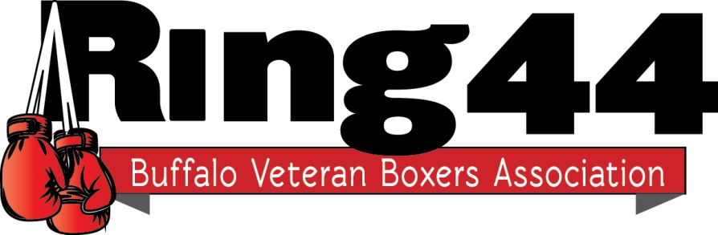
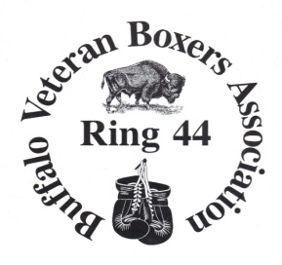

Membership Application

Yearly Dues: $25.00 Period: January 1 to December 31, 2017

Application Date: _____________________

Name: ________________________________________________________

Address: ______________________________________________________

City, State and Zip: ______________________________________________

Phone number: _________________________________________________

E-Mail: _______________________________________________________

Make checks payable to: BVBA Ring #44

Mail payment to: Bob Caico
334 Sanders Rd.
Buffalo, NY 14216

Any questions please call 440-1715

